ICSOC 2015 (International Conference on Service Oriented Computing)
ICSOC WORKSHOPS 2015
Goa University Campus, Goa, India
November 16, 2015 Monday

Venue Code | Place | Event
M1 | First Floor Foyer, Main Building, Goa University | Registration
M1 | Conference Hall | Inaugural, Keynote & Panel Discussions
M1 | First Floor Foyer, Main Building, Goa University | Tea/Coffee
M1 | Conference Hall | WS1 ( WESOA)
C1 | Hall, Office Block, Computer Science Dept | Lunch
C1 | MCA Lab 1, Office Block, Computer Science Dept | WS2 (ISCBRM (Joint Workshops of RMSOC'15 & ISC'15 & BSCI'15 )
C2 | MCA Lab 2, Block C, Computer Science Dept | WS3(Joint Workshops of WESE & FOR-MOVES)
C2 | MCA Lab 4, Block C, Computer Science Dept | WS4(DISCO)

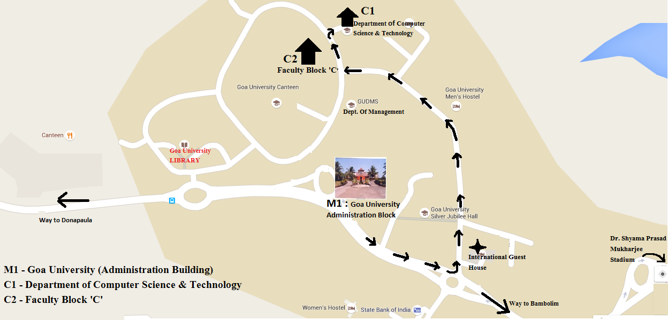

Contact for Assistance:
M1 – 0832-6519260 C1 – 0832-6519272 C2 – 0832-6519385

Faculty Contact:
Ramrao Wagh (9423882964 ) S Baskar (9404455723 ) Vandana Naik(9421247099 )
Volunteer Contact:
Nandesh Naik(7769092893) Priya Lotlikar(9890493704 ) Gaurang Bane (9881425995)

